Hippo Billing System

Overview
Hippo Billing System will handle all billings from provider, the provider send the patient information to Hippo Billing offline, the Hippo Billing staff will add/edit the patient's facesheet, financials, superbill, document and statement, and request for payment from patient's insurance company and patient. The insurance will pay according to the agreement, and return the adjustment amount and the balance the patient should pay. The provider can get the balance of the patient, and send/re-send the statement to patient when the patient does not pay, write-off the balance after the patient has paid, and also send the patient to Collection if the patient reject to pay.

Login
There will be 3 kinds of users to login the system, Provider/Staff, Hippo Billing Staff and Admin.
Forgot Password/ Password Verification
The user can request to change the password when he forgot password. The system will send an email with a link contains the verification code to change the password.
Change Password
The user click the link with the verification code which is requested before, then enter and repeat the new password to change the password.

Home
A dashboard with the practice list (All | Active | Inactive), the user will be redirect to view all patients of the clicked practice. Only the admin can add a new practice, the procedure will like this "One the user clicks on Add Practice button, a new account tab will open that is blank. The user will be brought to the Settings module. They user will enter in the practice information in the General section. Once the user saves the information, then the Account tab up top will then show the information that was enter in by the user. For example, once the user clicks on Add Practice, the Account tab will say Account X. The user will enter in Dr John Smith, then the Account tab will say Dr John Smith up top once he/she hits save. Then the user can into User Privileges and assign users to the Account Dr John Smith"

Patients
Patient List - Search by first/last name or DOB, Quick guide by Recently Viewed and Recently Created. The Hippo Billing staff can add/edit the patient information according to the information provider sent.
Facesheet section includes Demographics and Insurance profile, the Demographics will be the base information of the patient. The Insurance will list all insurance profiles and self-pay information of patient. The user can add new Insurance Profile, once the user clicks on the New Insurance Profile button, it brings up a pop up screen with the Favorites tab as default.

Responsibility party : There are times that a patient is in the hospital and someone else will be responsible for the bills so it will be defaulted to self but the user must have the option to change the responsibility party to someone else. There is no screen for this and we need to create one. Here is a screen shot of what it should look like. It will default to patient unless the user uncheck the box.
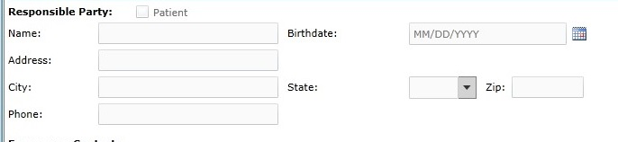
UI Changes:
1. Remove New Self Pay Profile button.
2. Add Responsible Party.
Financials section will list all financial information. The financial record is the summary of the superbill information and payment information on the superbill. User can't be adding manually any financial information.
Supberbills section will list all supberbills generated for the patient. The user can add a new superbill for the patient, once the user clicks on New Superbill, it will bring the user to the New Superbills in menu Superbills.
Documents section list all documents associated with the patient.
Statements section will list all statements of the patient. The system will generate the statement after the superbill has been paid by the insurance or the user manually clicks on Bill Patient (Go to Financials, Click on a line item, then there is a Bill Patient button). The statement section in Financials is to show the user what statements have been sent. The user can click on one and see the statement that was sent.

Authorization
The provider will request the authorization to make sure the insurance can be paid, the Hippo Billing staff will contact the insurance company the confirm and mark the request as complete. The insurance procedures(profiles) will repeated, each procedure will say #x (1,2,3 etc.) Insurance Procedure.
It should be repeated but it should say #2 Insurance Procedure. Once the user clicks on New Authorization, the Provider Name will show the provider listed within the practice. If there is only one, then it will default to that provider. If there are multiple providers, then the user will be required to choose a provider. Once the user chooses that provider, then the provider NPI will appear next to the provider name. Within the Location section, if there are multiple locations, then the user will be required to choose a location. We may want to add an area in the settings menu that will allow the user to be able to select defaults or we can add that in the UI and have a box that says “Mark as Default” next to provider and location. The user will then need to add a patient. Once they click on the spyglass (can we find a better spyglass than the one used or have it appear in the box rather than next to the word. This is happening in other areas of the application so if we do it here, we need to do it everywhere), the search patient box appears. The user selects a patient and the insurance profile information that is stored within the facesheet (it there are multiple, then the system will default the primary profile but the user will be able to change it since it will be a drop down. If the insurance profile is not active, and the user selects it, then it will be marked in red and say it is Not Active or we can make it that only active insurance will be available for selection) will appear. Looking at the UI, you will need to duplicate the policy # and group # field to be in align with Insurance Profile #2. The DX box will be lower down to be even with CPT/HCPCS box. Both CPT/HCPCS and DX code boxes will be free form text. The policy # and group # boxes will be greyed out and the user will not able to alter them once a patient is selected. Once the user (hippo billing staff) goes to the next area, they will select “yes” and “no”. Can you please fix the white and blue buttons as they are not filled in properly and you can see white still on the side. Also, the amount remaining, deductible, etc are not properly aligned with the selections to the left. Lastly at the bottom, there is mark as completed, save changes or cancel. I was thinking about moving those boxes up top where it says “View Notes” and getting rid of view notes. Let’s put a free form box at the bottom called “Notes” and the user can enter in the notes from the conversation with the insurance company there. It does not have to be a huge area but have it go the width of the page but only allow it to go 10 lines down. Our notes with the insurance company are not too extensive.
When the user selects an end date to the insurance within the insurance profile, it will make it inactive.
Q&A
Q: When will the provider request the authorization? Is it possible the provider request an authorization with a not existed patient in Hippo Billing System, and we need to add the patient information first, then add new authorization?
A: This is a great point and I have been thinking about this. If the patient is not listed in the application, the user will be able to send a yammer notification to be posted on the network wall asking that the patient be added into the system so that we can put it in. I don’t want the doctor staff to enter in patient information as we have done this in the past and it resulted in many errors and it caused a lot of disruption. This is the site for the yammer api: https://developer.yammer.com/Documentation/
Q: What will happen after the user Mark as complete? How will the provider who request the authorization get the result, how will the provider deal with if the authorization is approved or rejected?
A: This is a great point. I was thinking about what notification system can we use to do this. We currently use Yammer as a communication tool between my staff and the practices. I was thinking once the user (my staff) marks it as completed, it could generate a yammer notification that will be posted on the company wall.

Superbills
There is no difference between this Superbills and superbill of patient, the user can find the superbill in the patient’s superbill section when you create one in the superbills module.
The procedures will be an API integration with supercoder.com. I will forward you the documentation.
When user click on post superbill, you are changing the status to Ready for Electronic Submission or Ready for Paper Submission. Once a superbill is being created, it will not have a status until it is posted or held. This depends on the insurance profile of the patient. If there is no payer id listed in the insurance company, then this will make the superbill Ready for Paper Submission status. If there is a payer id listed, then it will go to Ready for Electronic Submission status.
Once you click on Hold Superbill, it will stay within the app and wait for it to be posted. Once it is posted and sent to insurance, you cannot put a hold on it again.
Repeat Last Superbill Procedure
Some patients come to the doctor often and many times the same codes are used from the previous date of service. Once the user clicks on this button, the previous superbill that was recently posted will show up and the dates of service will be set to present day. For example, if the user hits the “Repeat Last Superbill”, it will bring up the previous superbill but the dates of service will 06/11/2014. The user can alter the superbill as they choose, change the date of service, add or delete codes, etc.

All status of Superbill:
1. Ready for Electronic Submission.
2. Ready for Paper Submission.
3. Ready to Bill Patient.
4. Superbill on Hold.
5. Eligibility Rejection.
6. Pending Insurance.
7. Pending Patient.
8. Denied.
9. Completed.
Status Transfer
Example for Electronic:
Create Superbill and Post Superbill - > Change to Ready for Electronic Submission (payer id must be present in the insurance company field)
Once this is done, the system will check the eligibility of the patients insurance. If there is data in the eligibility payer id field (this is similar to the payer id), then the system will run an eligibility test (this is being done by the other developer. They will develop the code to do the call out, send the information to Emdeon, parse the response, etc.) If it fails the eligibility test, then status - > Eligibility Rejection. If it passes - > Ready for Electronic Submission
Create Superbill and Hold Superbill - > Change to Superbill on Hold
Create Superbill and Post Superbill - > Change to Ready for Paper Submission (payer id is not present in the insurance company field) – This will not go through the eligibility test.
Sent to Insurance company -> Change to Pending Insurance
Scenario 1
Return from Insurance company -> Payment was made on the superbill and there is no secondary insurance and there is no balance that the patient owes- > Change to Completed
Return from Insurance company -> Payment was not made on the superbill - > Denied
User can then resubmit the superbill if they want to. If they do then:
Once this is done, the system will check the eligibility of the patients insurance. If there is data in the eligibility payer id field (this is similar to the payer id), then the system will run an eligibility test (this is being done by the other developer. They will develop the code to do the call out, send the information to Emdeon, parse the response, etc.) If it fails the eligibility test, then status - > Eligibility Rejection. If it passes - > Ready for Electronic Submission
Scenario 2
Return from Insurance company -> Payment was made on the superbill and there is no secondary insurance and there is a balance that the patient owes- > Change to Ready to Bill Patient
Bill to Patient -> Pending Patient
Statement sent to patient -> Patient pays balance in full -> Status changed to Completed
OR
Statement sent to patient -> Patient pays partial balance -> Status changed to Ready to Bill Patient
Bill to Patient -> Pending Patient
Another statement sent to patient -> Patient pays balance in full -> Status changed to Completed. If they don’t pay in full, the above is repeated until they pay in full or sent to collections.
Scenario 3
Return from Insurance company -> Payment was made on the superbill and there is a secondary insurance - > Change to Ready for Electronic Submission (payer id must be present in the insurance company field)
OR
Return from Insurance company -> Payment was made on the superbill and there is a secondary insurance - > Change to Ready for Paper Submission (payer id must is not present in the insurance company field)
Once this is done, the system will check the eligibility of the patients secondary insurance. If there is data in the eligibility payer id field (this is similar to the payer id), then the system will run an eligibility test (this is being done by the other developer. They will develop the code to do the call out, send the information to Emdeon, parse the response, etc.) If it fails the eligibility test, then status - > Eligibility Rejection. If it passes - > Ready for Electronic Submission
Sent to Secondary Insurance Company -> Change to Pending Insurance (regardless if it was sent electronically or via paper)
Return from Secondary Insurance company -> Payment was not made on the superbill - > Denied
User can then resubmit the superbill if they want to. If they do then:
Once this is done, the system will check the eligibility of the patients insurance. If there is data in the eligibility payer id field (this is similar to the payer id), then the system will run an eligibility test (this is being done by the other developer. They will develop the code to do the call out, send the information to Emdeon, parse the response, etc.) If it fails the eligibility test, then status - > Eligibility Rejection. If it passes - > Ready for Electronic Submission
OR
Return from Secondary Insurance company -> Payment was made on the superbill and there is no third (it is called tertiary) insurance and there is no balance that the patient owes- > Change to Completed
Return from Insurance company -> Payment was not made on the superbill - > Denied
Return from Insurance company -> Payment was made on the superbill and there is no third (tertiary) insurance and there is a balance that the patient owes- > Change to Ready to Bill Patient
Bill to Patient -> Pending Patient
Statement sent to patient -> Patient pays balance in full -> Status changed to Completed
OR
Statement sent to patient -> Patient pays partial balance -> Status changed to Ready to Bill Patient
Bill to Patient -> Pending Patient
Another statement sent to patient -> Patient pays balance in full -> Status changed to Completed. If they don’t pay in full, the above is repeated until they pay in full or sent to collections.
---Any time there is Denied status, the user can resubmit the claim as many times as they want or need to or write it off.---

UI Changes:
1. Add a print button next to the Post Button to change the status to Pending Insurance.

Emdeon
Embedded this link in this page. Once the user clicks on Emdeon heading, it will bring the user to this page. https://www107.medi.com/Portal/AccountLoginNew.faces

Payments
We will record the paid information for each superbill that does not come in electronically from the insurance and when there is a patient payment made towards that superbill. User can add multiple superbills in one payment.
User can only select one of the tabs Patient and Insurance one time to apply the payment, and grey one of them out in Apply Tab once the user selects one or the other.
Once you are posting a patient payment, you cannot switch the tab to Insurance. If the user does, then a pop up will show asking the user to say the patient payment first before they go and post an insurance payment.
Pat Resp is what the patient owes after the insurance has paid.
There is no list page for payment and will create the report to instead of list page.
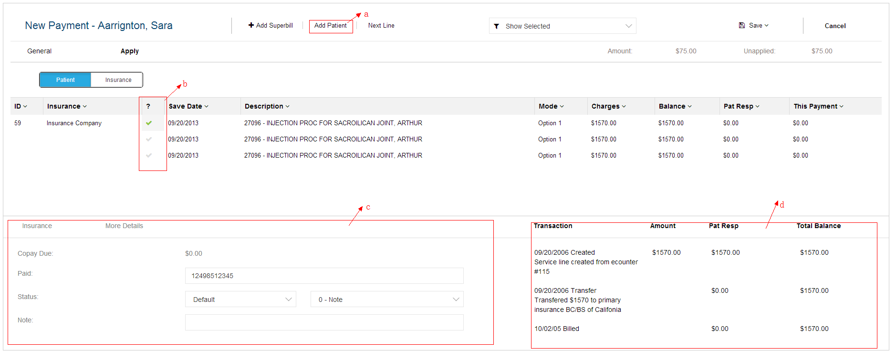
There are a couple issues with UI. When the user selects Patient and not Insurance, the field underneath should be labelled Patient with a spyglass. The user will click on the spyglass and the search patient window will appear. Underneath the patient search box should be a field called Payment Date. If the user selects Insurance, then the UI that is place now is fine. I have not figured out why this is 2 apply now buttons. Get rid of the Apply next to General and take the functionality from the Apply and move it the Apply Now green button.
Once again, a few UI issues. Once the user selects the patient tab, the add patient will not be there since we have selected the patient already. Also, it should not insurance right next to ID, it should be patient and underneath that, it should say patient as well next to more details. Get rid of Next Line.
Once you select the option in B, it will affect label C. I select the first line, the user will enter a paid amount. Then the user will select the next box. Once again, they will enter a paid amount. As they are entering these paid amounts, it is decreasing the amount in unapplied amount. Get rid of Copay Due, 0 - Note and also More Details.
This is a snapshot from the financials section for this patient/superbill. As you are posting a payment, patient or insurance, it is showing you what that transaction line will look like when you have posted the payment and go back into financials. I am not sure if we should keep it or not.
A superbill will consist of one to many transactions. What is listed above is 1 superbill with 3 transaction listed within it.
The information filled in C will not be saved until the user clicks on the Save button and then all payments made for those 3 transaction line items will be applied to the superbill.
The record which filled in label C (decreasing amount) will display in label D (Transaction)

Electronic payment procedure
The electronic payment is what the other developer will work on. They will parse the payment information coming from emdeon. It will go into the same tables and fields that you create for this payment module. There is an additional page that we need to create but I have not thought about howq to do it yet. We need a page for conflicts. The information that comes back from Emdeon may not match up to what is listed in the application…the user could have changed the date, etc. Also, when we sign a new client, there are payments going to be coming into the application from superbills that the previous company had sent in. We need a place to see those and ignore them. We can discuss this when we get closer to the payment module.

UI Changes:
1. Remove Apply tab next to General.

Collections
All patients who does not pay in time will list here, the provider and Hippo Billing staff can send the patient to the Collections, re-send the statement to patient and write-off the balance until the patient paid.

Reports
Coming soon.

Settings
General
The general will be used for adding a new practice, all other tabs will be related to the practice.
NPI records will be a third-party supplier, go to this link: http://nppes.viva-it.com/NPI_Files.html . You will download the Full Monthly Replacement File. It is rather large. Part of the maintenance plan we will set up with you is to have this file downloaded into the system every month so it is up to date with all the providers and their NPIs.
There will only two status Active and Inactive for general setting.
There will a new form if the user select use different address, like this
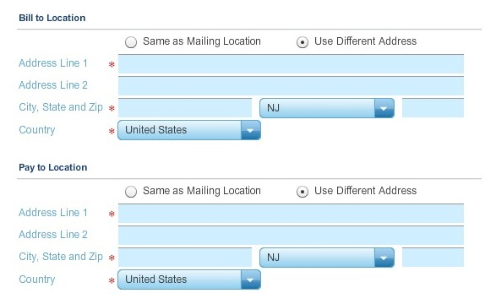
Providers
Add/edit the provider information, and bind a user account to provider so that the provider can login to system.
Remove the SSN field as the provider does not need it, only for patient. (xxx-xx-xxxx)
Locations
The difference between Location and Practice :
The Practice is the location of the business as it is registered with the government (This is listed in the General Section of Settings). The Location is where the physician performs medical services. So the practice and location can be the same but some physicians have multiple offices so when we send in the superbill, it will have the practice location which is the government registered tax id and it will also have the location that he performed the medical services. The location (service location) does not have a tax id associated it when it is submitted with the superbill, just the NPI. The Practice (this is the information that is listed in the General section of Settings) has the tax id and the NPI that get sent with the superbill to the insurance company.
Each location and each provider has an NPI assigned. The provider will have an NPI that will never change. His practice will have one NPI that is associated to his tax id. The locations he practices at, remember they can have multiple offices so each location will have its own NPI.
UI Changes:
1. Change the NPI dropdown list in Practice to the Lookup like it in Provider.

Claims (Superbill)
This will be superbill settings, and the settings will be applies to superbill.
Assemble Claims Automatically (this should say Assemble Superbills Automatically) – this should be a yes or no or a check box. We are going to be sending superbills every hour. This setting will prevent the system from sending them automatically. We have this as sometimes Emdeon is not ready to accept the superbills but we have received them from the providers office so rather than putting them all on hold, then we just post them, wait for notification from Emdeon to send them and then turn this on once we get notification.
Display Supervising Provider – This will list the providers that are within the account and there will be a selection of None as well. This is used for superbill submission. If a provider is selected, then it will be accompanied on the XML string that is being submitted to Emdeon
Write off Medicaid – This is business logic that is applied to the insurance profile of the patient. If we send in a superbill that has Medicare insurance primary and Medicaid insurance secondary, some providers are not enrolled in the Medicaid insurance plan so they will not get paid for the Medicaid portion. This feature, when it is selected, will automatically adjust off the secondary amount after Medicare has paid it primary amount.
Display Attending Provider - This should be a drop down. This will list the providers that are within the account and there will be a selection of None as well. This is used for superbill submission. If a provider is selected, then it will be accompanied on the XML string that is being submitted to Emdeon
Auto Apply/Unapply Patient Payments – this will be a check box. The business logic behind this is that what the user posts a patient payment and there is a credit left over, the credit will apply itself to the next insurance payment that comes in and leaves a patient balance.
Release of Information – drop down menu of information attached to email. This is information that is used for sueprbill submission and it will be accompanied on the XML string that is being submitted to Emdeon.
Use of Primary Config – get rid of this
Default State – this will list all of the states in the United States in alphabetical order. This should be moved to the General tab within Settings. Every time a new patient is created, the state will automatically default to this selection. Need to include a None here as well as some providers have office in multiple states.
Default Provider – this will be a list of the providers within the account. This should be moved to the General tab in Settings. Every time a new patient is created, the provider will automatically default to this selection. Also, when the user goes to create a superbill, this default selection will carry over as well.
Default Service Location - this will be a list of the locations within the account. This should be moved to the General tab in Settings. Every time a new patient is created, the location will automatically default to this selection. Also, when the user goes to create a superbill, this default selection will carry over as well.
Request of Information – please remove this
Signature Source – default value should be: Generated by Provider. This is needed for Emdeon superbill submissions.
Accept Assignment– drop down info provided in excel sheet. This is needed for Emdeon superbill submissions.
Assignment Indicator – check box and it is checked by default. This is needed for Emdeon superbill submissions.

UI Changes:
1. Remove Use of Primary Config
2. Remove Request of Information
Eligibility Config
It is listed in Facesheet, Insurance. There is a check eligibility button listed there. This is something that the EDI developer will work on. This is business logic that will tell the system which NPI to use when running this logic.
No Eligibility page as we will be receiving back a PDF from Emdeon.

Fee Schedules
This will apply the different level charge amount for the corresponding providers, locations and insurance payers in superbill. The user can add a new payer in Facesheet - Insurance. The Medicare Fee Schedule Multiplier will used in superbills, it will be associated to the procedure, insurance company listed in the patient insurance profile and total charge amount.
UI Changes:
Remove Contract Rates Tab
Remove Settings Tab
Confirmation:
1. The Medicare Fee Schedule Multiplier
The procedure may like this the admin add the provider, location and payer and enter in a multiplier for a fee schedule named 'FS1', when the hippo billing staff adding a new super and the provider, location, payer id hit the values which admin added in Fee Schedules Settings, the charge amount total will multiply by the Multiplier in each procedure row.

Users
Add user account and assign the permissions privileges.
The account will be assigned to one or multiple practices.
The admin can create account or select an existed one to assign to the practice.
The permissions of the user account will be just for current practice.

User Information
Please get rid of My Profile, My Task , My Calendar and My Inbox as we do not need them.

API
1. NPI records will be a third-party supplier, go to this link: http://nppes.viva-it.com/NPI_Files.html .
Need to sync the data every month, import via excel or WebApplication Task or Window Service
2. Procedure records in superbill, http://supercoder.com
Get real-time data by the input parameters when adding superbill.
3. Emdeon, https://www107.medi.com/Portal/AccountLoginNew.faces
The EDI developer will work on.
4. Communication Tool between Provider and Hippo Bill Staff https://developer.yammer.com/Documentation/

